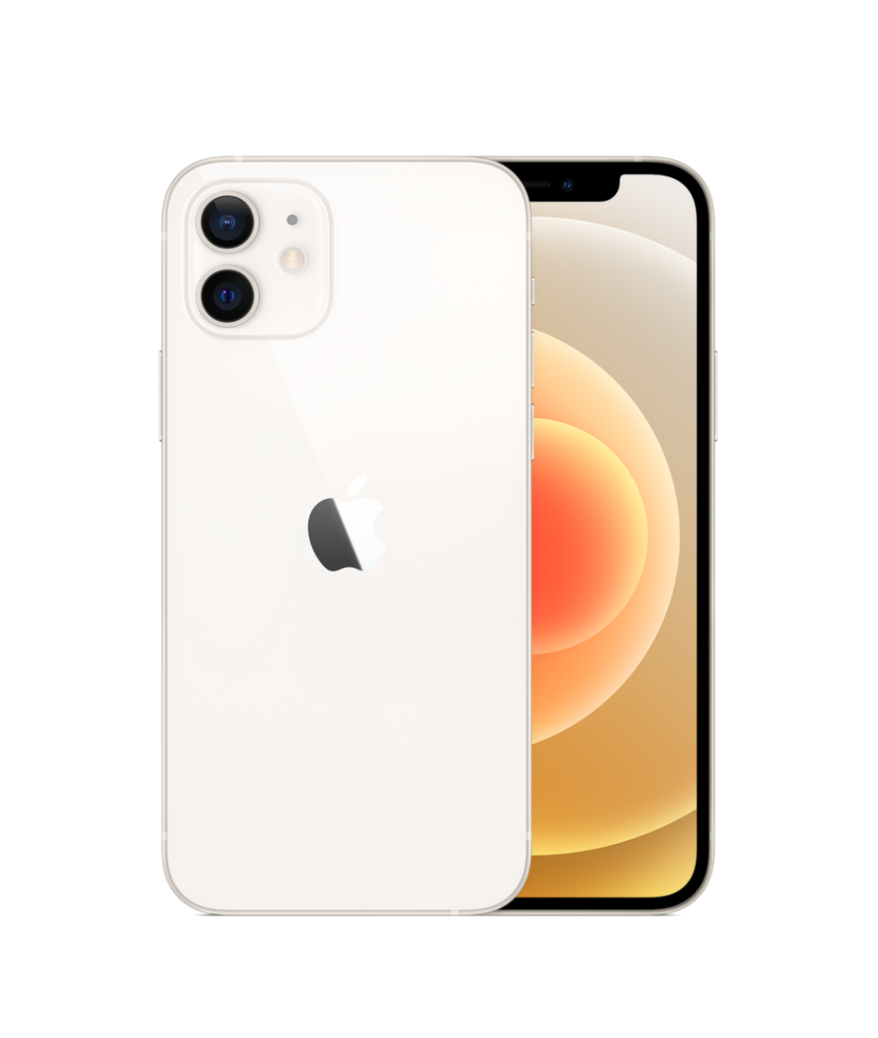

Price: [$ 257.00](https://www.gsmarena.com/apple_iphone_12-price-10509.php)

2815

* Apple iPhone 12
* Processor: Apple A14 Bionic (5 nm)
* Front Camera: 12 MP
* Rear Camera: Dual: 12 , 12 MP
* Display: 6.1 “
* NFC: Yes
* Colors: Black, White, Red, Green, Blue, Purple
* Operating System: iOS 14.1
* Charging Type: Lightning, USB 2.0
* SIM: Nano-SIM and eSIM or Dual SIM
* Fingerprint: No
* Release Date: 2020, October 23

RAM

4

GB

ROM

256

GB

BATTERY

mAh



+001-28272300-2466-2469



webmaster@cellinfo.com



A-65, ACME Co. ,

Street No. 12,

New York

Ask Me Ltd.